Task 1: Adidas Case Study - OKRs (Objective Key Result)

1️⃣ Objective
Objective:
Increase Adidas sales performance while maintaining strong profitability.
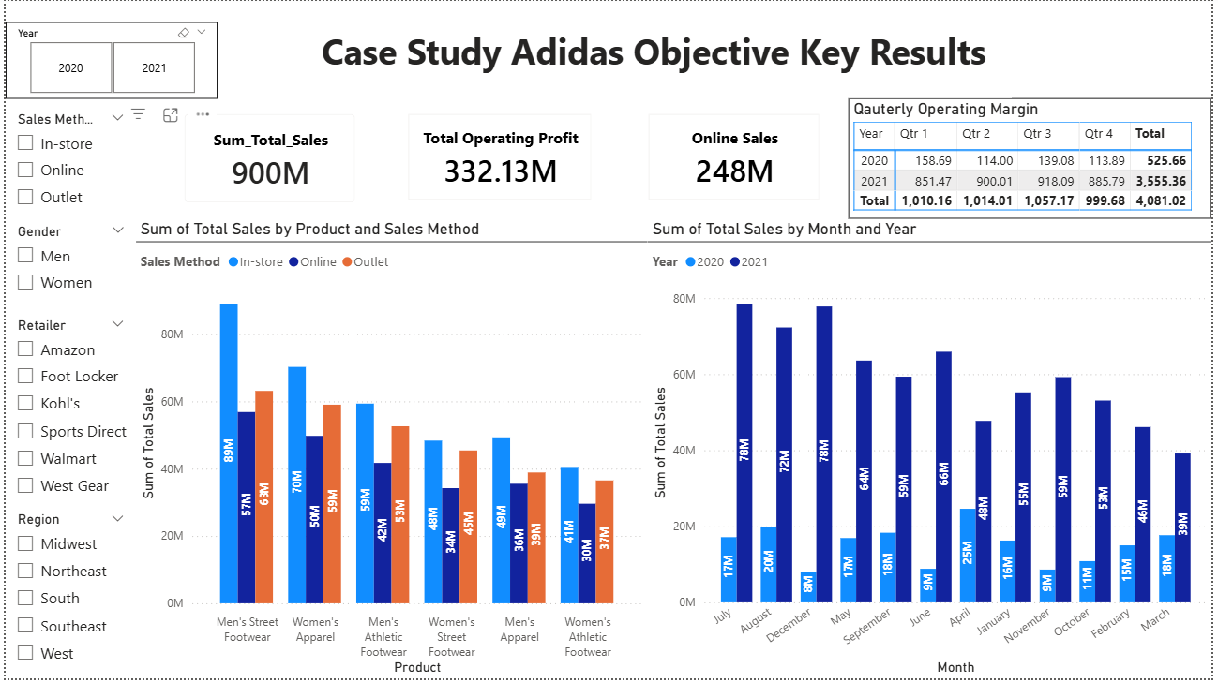
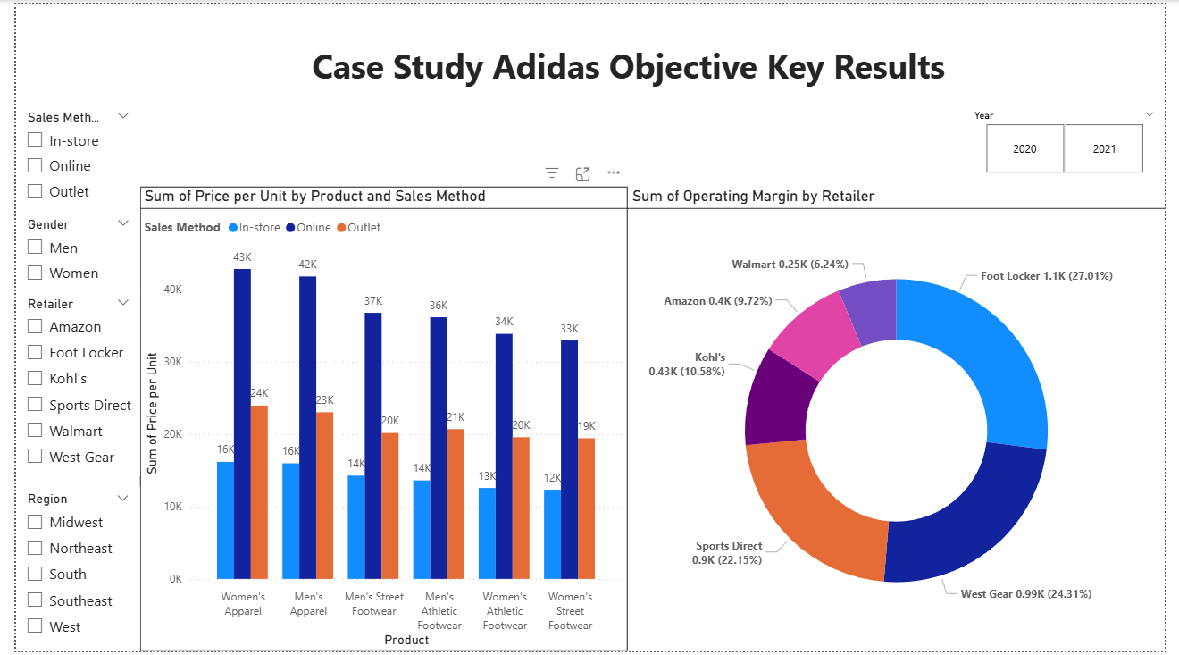

2️⃣ Key Results

Key Result | KPI Used
Increase overall revenue | Total Sales
Improve profitability | Total Operating Profit
Maintain healthy margins | Operating Margin
Grow digital sales | Online Sales

3️⃣ How the Dashboard Tracks OKRs
- KPI Cards show overall progress on sales, profit, and online contribution.
- Monthly Sales Trend (2020 vs 2021) tracks year-over-year growth.
- Product & Sales Method chart identifies high-performing products and channels.
- Retailer Margin chart highlights retailers contributing the highest profitability.
- Slicers allow focused analysis by year, region, product, retailer, and channel.

4️⃣ Key Insights
- Sales in 2021 are significantly higher than 2020, indicating strong growth.
- Men’s Street Footwear and Women’s Apparel are top revenue drivers.
- In-store sales dominate, but online sales show strong contribution.
- Foot Locker and West Gear generate the highest operating margins.
5️⃣ Success Factors
- Clear, measurable KPIs aligned with business objectives.
- Power BI enables continuous tracking of Key Results.
- Data-driven identification of profitable products and retailers.
6️⃣ Challenges
- High dependence on in-store sales.
- Profit margins vary across retailers.
- Seasonal fluctuations affect monthly sales.
7️⃣ Conclusion
This OKR-driven Power BI dashboard helps Adidas monitor sales growth and profitability using measurable KPIs, enabling data-driven decision-making and strategic focus.

